Scenario:
Task #1
You are tasked with creating a basic grocery store checkout system using Python. The program will:
∙ Ask the user for their name.
∙ Allow the user to input the price of three grocery items they are purchasing. ∙ Calculate and display the total amount.
∙ If the user enters an invalid value (such as a negative price or non-numeric input), the system should handle the error and prompt the user to re-enter the correct price. ∙ Once the total is displayed, the program will ask if the user wants to apply a membership discount. If yes, the total amount should be recalculated with a 10% discount.
Task Description:
This scenario covers input/output, data types, error handling, and numerical operations.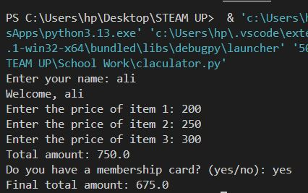
def get_price(item_number):
while True:
try:
price = float(input(f"Enter the price of item {item_number}: "))
if price < 0:
print("Error: Price cannot be negative. Please enter again.")
else:
return price
except ValueError:
print("Error: Please enter a valid number.")

def main():
name = input("Enter your name: ")
print("Welcome,", name)

total = 0
for i in range(1, 4):
total += get_price(i)

print("Total amount:", total)

choice = input("Do you have a membership card? (yes/no): ").lower()
if choice == "yes":
total = total - (total * 0.10)

print("Final total amount:", total)

main()

Task #2
Scenario: You are tasked with creating a simple calculator program in Python. The program should:
1. Ask the user to input two numbers.
2. Ask the user to choose an operation (addition, subtraction, multiplication, division). 3. Perform the chosen operation on the two numbers.
4. Display the result.
5. If the user attempts to divide by zero, the program should catch this error and display an appropriate error message without crashing.
Task Description:
You are tasked with creating a simple calculator program in Python
def calculator():
try:
num1 = float(input("Enter first number: "))
num2 = float(input("Enter second number: "))

print("\nChoose an operation:")
print("1. Addition (+)")
print("2. Subtraction (-)")
print("3. Multiplication (*)")
print("4. Division (/)")

choice = input("Enter your choice (1/2/3/4): ")

if choice == "1":
result = num1 + num2
print("Result:", result)
elif choice == "2":
result = num1 - num2
print("Result:", result)
elif choice == "3":
result = num1 * num2
print("Result:", result)
elif choice == "4":
try:
result = num1 / num2
print("Result:", result)
except ZeroDivisionError:
print("Error: Cannot divide by zero.")
else:
print("Invalid choice.")

except ValueError:
print("Error: Please enter valid numeric values.")

calculator()
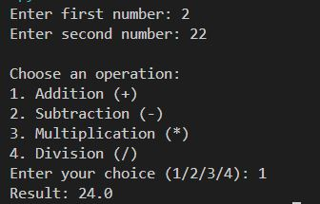

Task #3
Scenario: You are creating a basic library book management system in Python. The program will allow the user to:
1. Initialize: Start with three predefined books.
2. User Actions:
o Add a new book to the library (check if it already exists).
o Check if a specific book is available in the library.
o Remove a book from the library (check if it exists).
Task Description: creating basic library management system using concepts of identity operators.
library = ["atomic habbits", "physics", "maths"]

def show_books():
print("\nCurrent books in library:")
for book in library:
print("-", book)

while True:
print("\n--- Library Management System ---")
print("1. Add a new book")
print("2. Check if a book is available")
print("3. Remove a book")
print("4. View all books")
print("5. Exit")

choice = input("Enter your choice (1-5): ")

if choice == "1":
new_book = input("Enter book name to add: ")
if new_book in library:
print("Book already exists in the library.")
else:
library.append(new_book)
print("Book added successfully.")

elif choice == "2":
search_book = input("Enter book name to check: ")
found = search_book in library
if found is True:
print("Yes, the book is available.")
elif found is not True:
print("No, the book is not available.")

elif choice == "3":
remove_book = input("Enter book name to remove: ")
if remove_book in library:
library.remove(remove_book)
print("Book removed successfully.")
else:
print("Book not found in the library.")

elif choice == "4":
show_books()

elif choice == "5":
print("Exiting Library System. Goodbye!")
break

else:
print("Invalid choice. Please enter 1–5.")

